**2019 System 21 Cloud Wizard Changes**

**TV Wizard**

Since many people may be inputting information on devices that have a smaller screen size, please enlarge to full-screen on the Wizard. This capability was an option on the previous Wizard but would be appreciated if we can make that standard. See below difference.

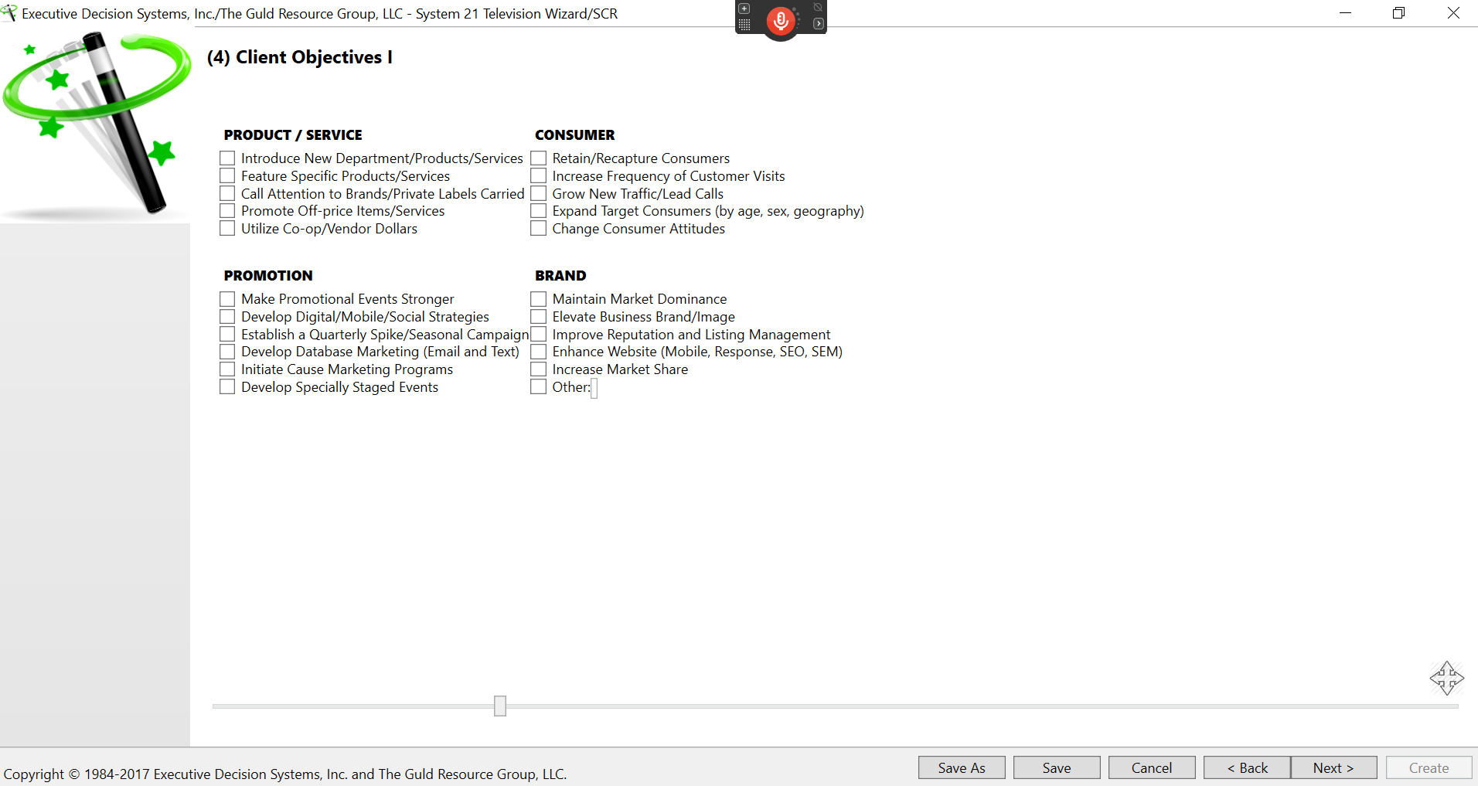

VS.

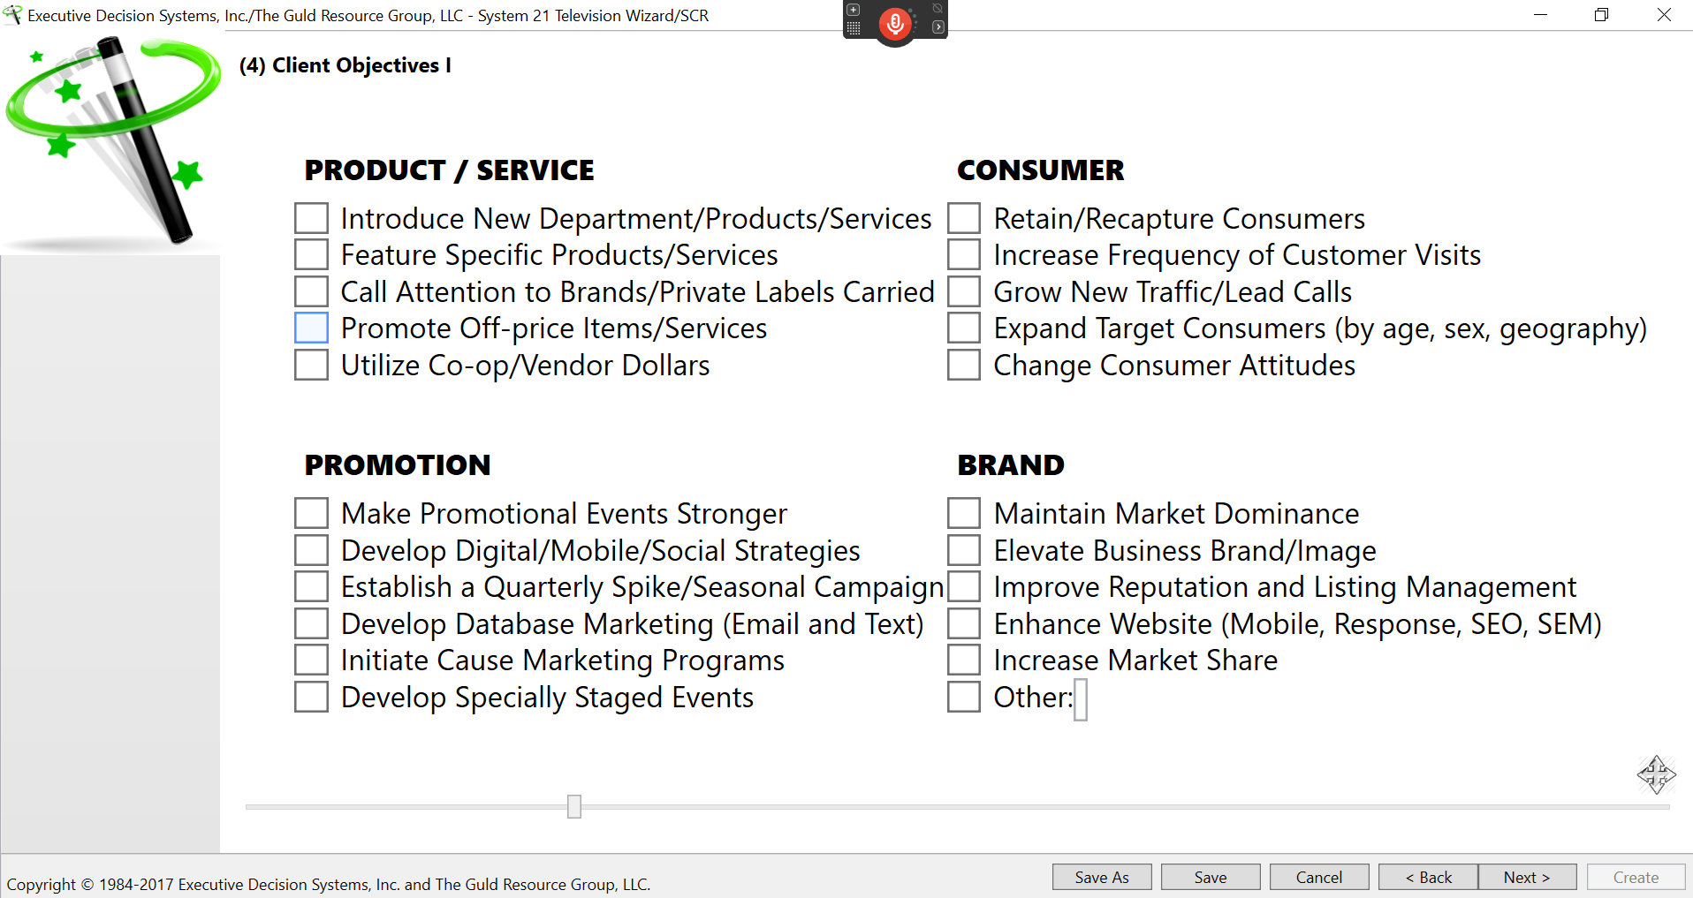

**Screen 6** - add to the below wording after “advantages?” (How you differ from the competition or “why” you?)



**Screen 7** - add to the below wording after “you get?” (their customers’/clients’ perspective)

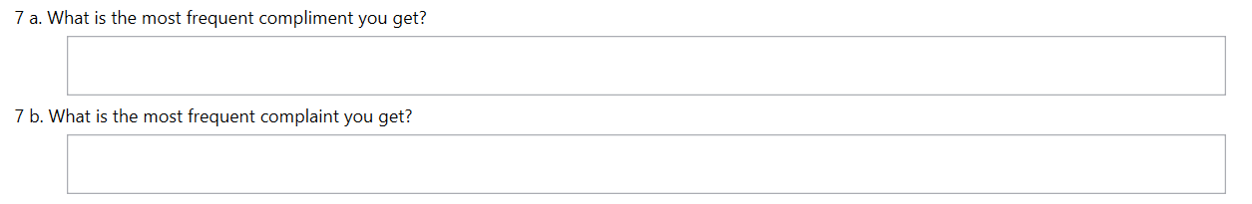

Screen 9 – the “Please use 0 vs. “Delete” for no value” was used because the “Total Media Investment” would did not calculate if the cell was “deleted.” If that is not the case once created in the cloud then you can take that sentence out. Also, once the numbers were input into the below it also provided a starting point for the next chart (auto filling the Media/Amounts) in “D. Proposed Media Allocation” on Screen 10.

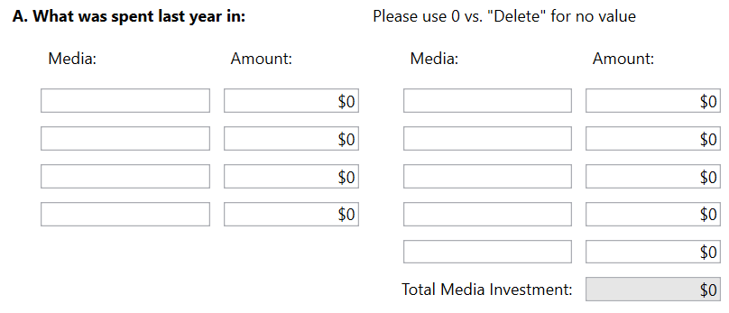

**Screen 10** – the “Import Plan A” was added in the event the Plan on Screen 9 did not autofill (which happens). If coded to automatcally autofill you can delete “Import Plan A” (below shaded).

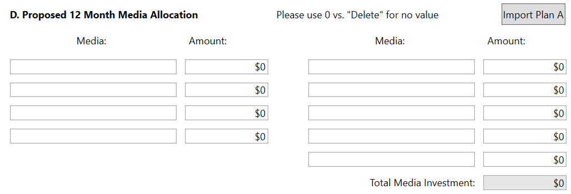

Please take off the arrows in the shaded portion below as it cannot be moved up or down.

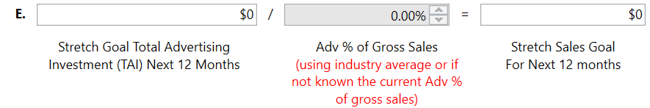

**Screen 19** - as with before in the Wizard please program so that all information typed into the Wizard on Screen 19 on the below gets auto filled on the Screen 20 Plan B (as a starting point that can be edited).

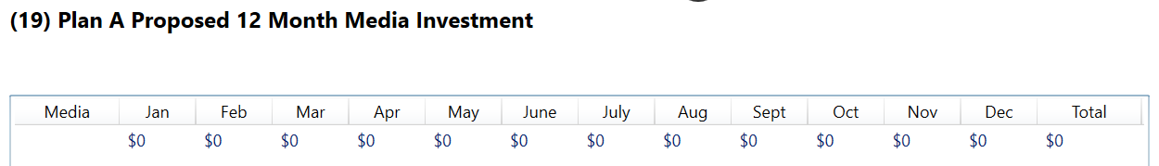

Is there any way to put in a fail safe that reminds users to select slow/spike months (below)? If Java is used, perhaps a pop up that includes an “ok” button simply reading “Note, be sure to select appropriate ‘slow/spike/base’ months in order for color coding to become enabled in SCR.’ Alternatively, perhaps more contrasting color could bring to their attention.



**The Summary of Conclusions and Recommendations (SCR)**

Please program so that any screens not filled out in the Wizard do not produce output or that individual slides can be deleted once produced. I am assuming that if it is creating a PDF it cannot be imported/converted to a PowerPoint and edited (and customized) but please advise if possible…that would be great.

I assume that this is going to be generating a PDF that can be viewed on screen and then printed out to 8 ½ x 11 pages. If possible, could the viewing on screen be full screen (vs. unused boarders on the sides)? We can discuss the feasibility of doing that because if so we would probably need to make the font type size larger for the headings, titles and text added.

Slide 1 - would it be possible to add a company logo to the right of “Mark Smith” (below example) and a set of broadcast group logos to the right of “Michael Guld?” If too complicated please advise.



**Slide 10** **- 14** - these slides were to be customized in the text boxes once the output slides (PowerPoint) were created. I am assuming that these screens would have to be re-created and text could be added in the Wizard before the output is created. If so, they would follow after Screen 8 in the Wizard as currently numbered.

I would also like to make it so that the headings (while auto-filling with the below) could be customized and additional slides on any of the below could be added to the presentations. For example, if a client wanted to add an additional slide of “Marketing Strategies” or wanted to customize the heading “Digital/Mobile/Social Strategies” to be specific to their offerings they could do so.

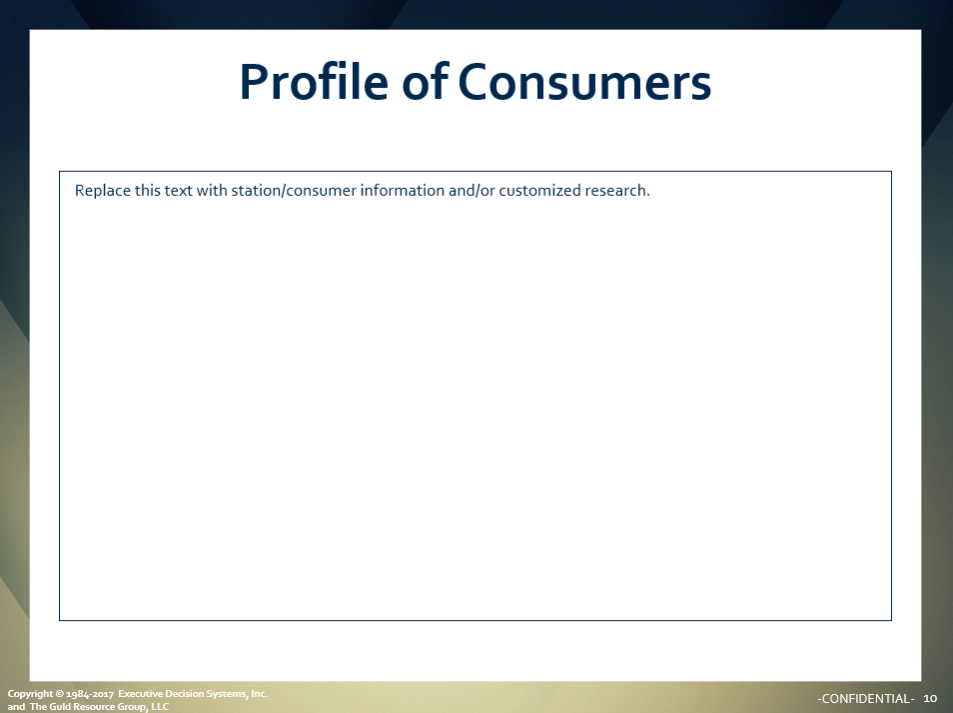

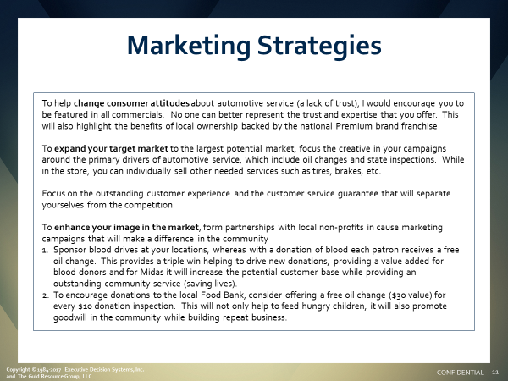

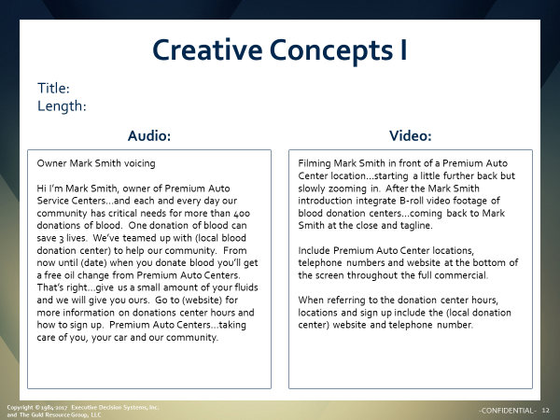

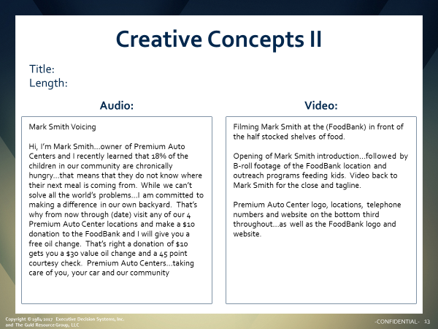

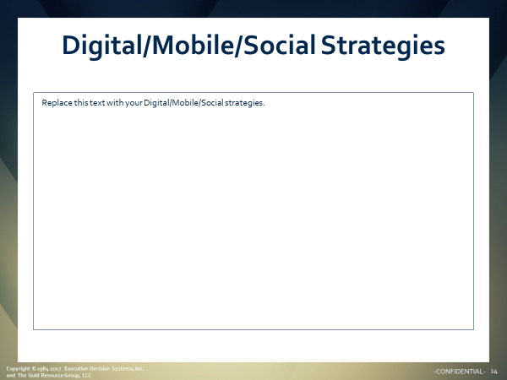

**Slide 17 and 23** - once a PowerPoint was created we would manually double-click in the bar charts in the PowerPoint below to convert the spike months to green, the slow months to red and the blue months as base months.

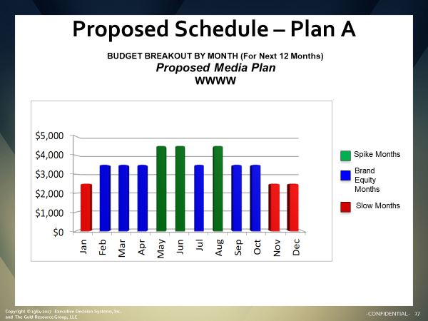

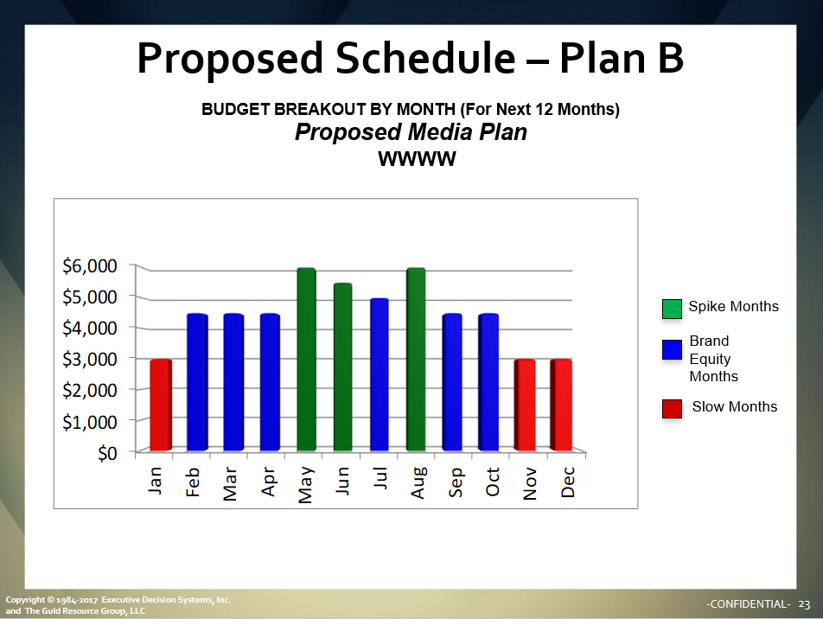

The color coding (Green Blue Red) was based on the below input in the Wizard on Screen 19



I am assuming there is a way to autofill the colors in the cloud version as I do not believe the output will be editable.

**Slide 18 and 24** - each of these slides contain embedded Excels. Once double-clicked we could input station schedules. I’m assuming each of these will also need to be included in the Cloud Wizard for inputting the schedules since the output will not be editable. As the screens are currently numbered in the Wizard…

Slide 18 in the PowerPoint (below) would follow Screen 10 in the Wizard

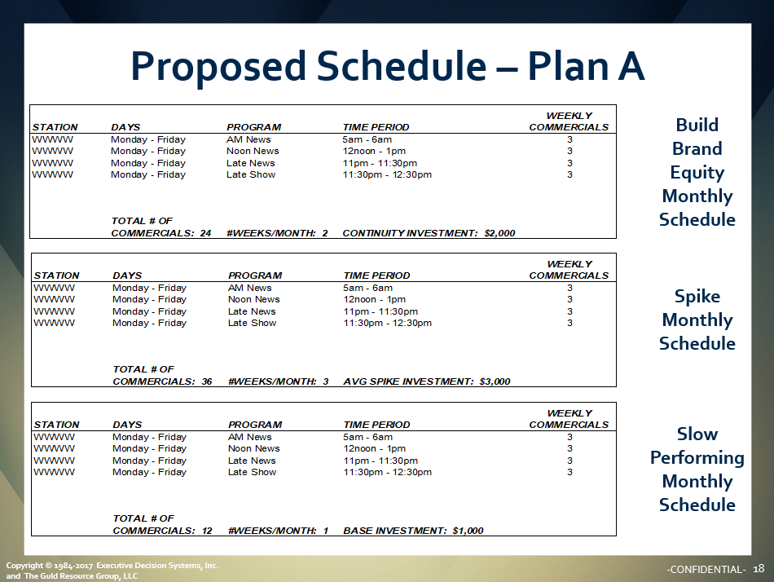

Slide 24 in the PowerPoint (below) would follow Screen 14 in the Wizard.

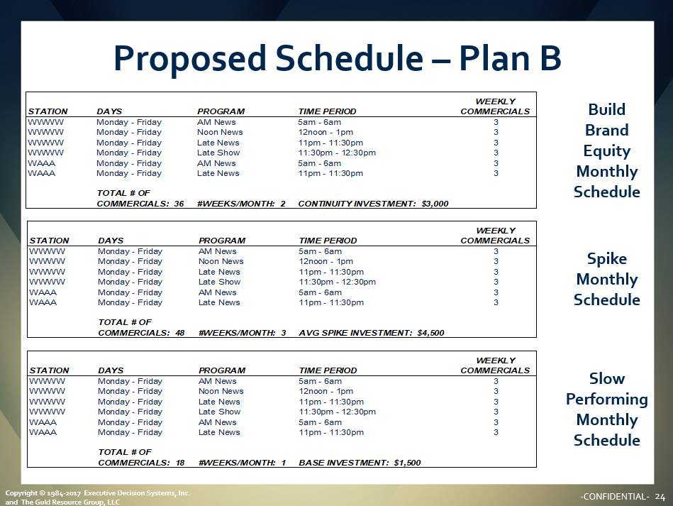

Slide 32 – please change the below “Account Executive” to “Integrated Marketing Specialist”



**Radio Wizard**

All will be the same with the exception of 4 output slides. See below…

**Slides 18 and 24 -** these two slides will be replaced with radio specific titles in the schedule and a single text box (vs. split screen w/ Audio and Video for TV).

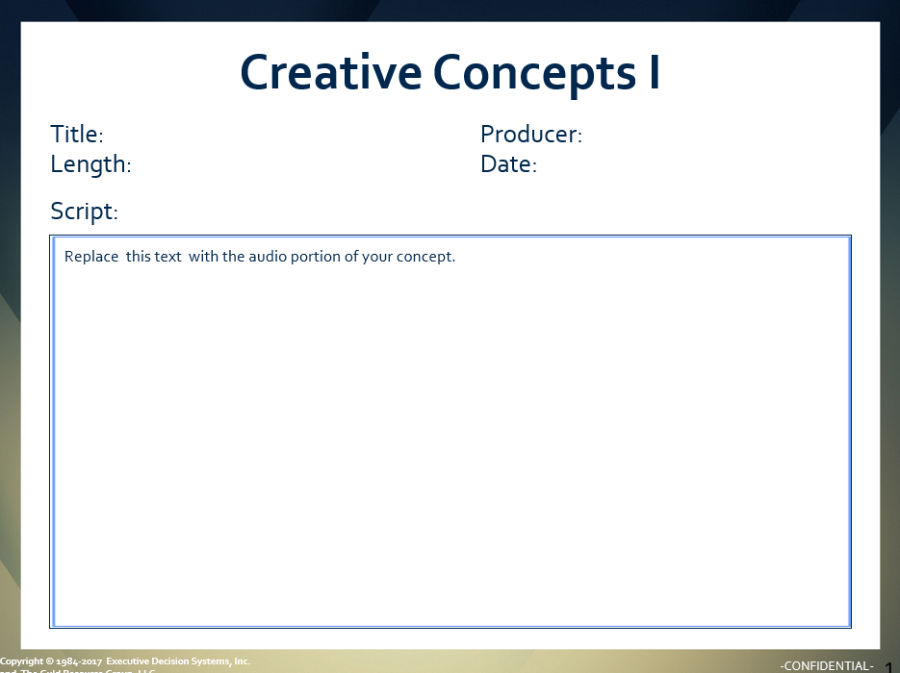

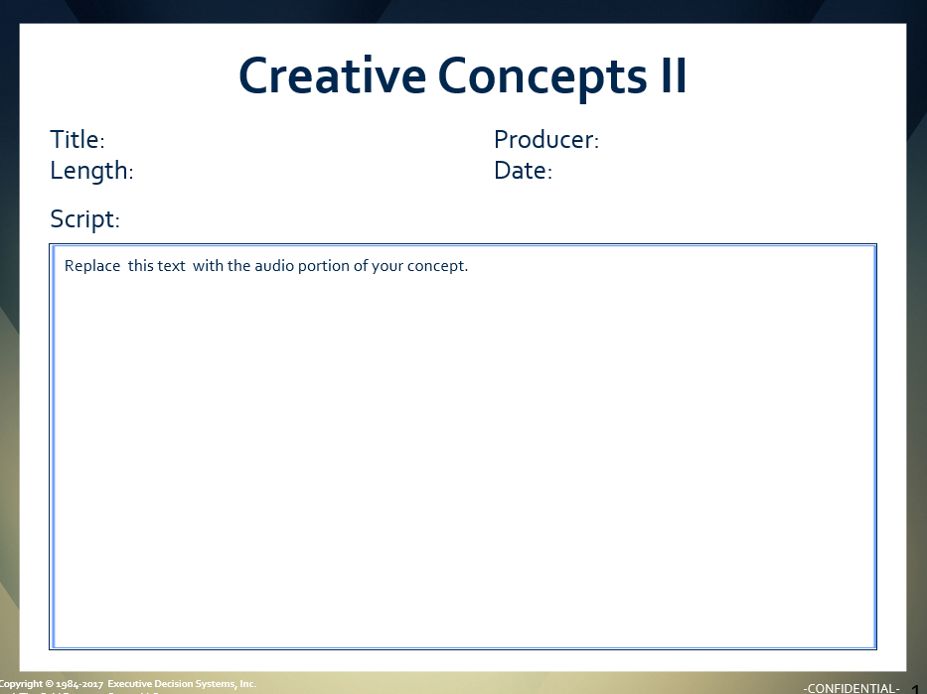

**Slides 18 and 24 -** these two slides will be replaced with radio specific titles in the schedule.

